***Mass Spectrometry (MS)- Principle, Working, Instrumentation, Steps, Applications***

* Mass Spectrometry (MS) is an analytical chemistry technique that helps identify the amount and type of chemicals present in a sample by measuring the mass-to-charge ratio and abundance of gas-phase ions.
* In this instrumental technique, sample is converted to rapidly moving positive ions by electron bombardment and charged particles are separated according to their masses.
* Mass spectrum is a plot of relative abundance against the ratio of mass/charge (m/e).
* These spectra are used to determine the elemental or isotopic signature of a sample, the masses of particles and of molecules, and to elucidate the chemical structures of molecules and other chemical compounds.
* Mass spectrum is a plot of relative abundance against the ratio of mass/charge (m/e).These spectra are used to determine the elemental or isotopic signature of a sample, the masses of particles and of molecules, and to elucidate the chemical structures of molecules and other chemical compounds.<img width="800" height="420" src="//163602-560839-raikfcquaxqncofqfm.stackpathdns.com/wp-content/uploads/2018/12/Principle-of-Mass-Spectrometry-MS.jpg" class="attachment-full size-full wp-post-image" alt="Principle of Mass Spectrometry (MS)" itemprop="image" srcset="//163602-560839-raikfcquaxqncofqfm.stackpathdns.com/wp-content/uploads/2018/12/Principle-of-Mass-Spectrometry-MS.jpg 800w, //163602-560839-raikfcquaxqncofqfm.stackpathdns.com/wp-content/uploads/2018/12/Principle-of-Mass-Spectrometry-MS-300x158.jpg 300w, //163602-560839-raikfcquaxqncofqfm.stackpathdns.com/wp-content/uploads/2018/12/Principle-of-Mass-Spectrometry-MS-768x403.jpg 768w" sizes="(max-width: 800px) 100vw, 800px" />

1. In this technique, molecules are bombarded with a beam of energetic electrons.
2. The molecules are ionized and broken up into many fragments, some of which are positive ions. Each kind of ion has a particular ratio of mass to charge, i.e. m/e ratio (value).
3. For most ions, the charge is one and thus, m/e ratio is simply the molecular mass of the ion.
4. The ions pass through magnetic and electric fields to reach detector where they are detected and signals are recorded to give a mass spectrum.

**Working of Mass Spectrometry (MS)**

* In a typical procedure, a sample, which may be solid, liquid, or gas, is ionized, for example by bombarding it with electrons.
* This may cause some of the sample’s molecules to break into charged fragments. These ions are then separated according to their mass-to-charge ratio, typically by accelerating them and subjecting them to an electric or magnetic field:
* Ions of the same mass-to-charge ratio will undergo the same amount of deflection.
* The ions are detected by a mechanism capable of detecting charged particles, such as an electron multiplier. Results are displayed as spectra of the relative abundance of detected ions as a function of the mass-to-charge ratio.
* The atoms or molecules in the sample can be identified by correlating known masses (e.g. an entire molecule) to the identified masses or through a characteristic fragmentation pattern.

**Instrumentation and Steps of Mass Spectrometry (MS)**

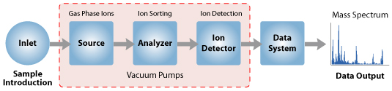

**Sample Inlet**

* Sample stored in large reservoir from which molecules reaches ionization chamber at low pressure in steady stream by a pinhole called “Molecular leak”.

**B. Ionization**

* Atoms are ionized by knocking one or more electrons off to give positive ions by bombardment with a stream of electrons. Most of the positive ions formed will carry charge of +1.
* Ionization can be achieved by:
  + Electron Ionization (EI-MS)
  + Chemical Ionization (CI-MS)
  + Desorption Technique (FAB)

**Electron Ionization**

Electron Impact (EI) is the simple and very much common method of ionisation. Heated filament made up of either Tungsten or Rhenium metal collides sample molecules which are in gaseous form which generates positively charged ions after removal of electron. The original molecule gets converted into fragments by this energetic ionisation technique. In Electron Impact, thermally volatile and stable compounds of mass range 500 Da are introduced. A beam of electron at a pressure of greater than 10-3 torr passes through a gas phase sample and collides with neutral analyte molecules (M) which produces charged ion or a fragment ion. 70 eV electron energy is required to form fragment ions. By collecting positive ions in focusing plates they are passed to mass analyser. Although EI has some limitation, EI causes extensive fragmentation so that the molecular ion is not observed for many compounds.

M + e- M+. + 2e

M+. A+ B+

Molecular ion Fragment ions

**Chemical ionization**

Chemical ionization (CI) is a soft ionization technique which is useful when no molecular ion is observed in Electron Impact mass spectrum. Comparatively lower energy requires to this process than Electron Ionizations. As softer ionization technique it gives less fragmentation and easier to find molecular ions. It involves the ionization of methane a reagent gas at comparatively high pressure (~1 mbar) in a common electron impact source. The gas phase reaction processes occur by colliding produced reagent ion gas with the analyte molecule where the proton transfer process takes place. Generally, methane, Isobutene and ammonia are used as reagent gases. There is a disadvantage for this technique. As there is no fragmentation it is less informative.

**Field desorption (DI)**

By applying high electrical field, gas phase analyte ions formation achieved from a material deposited on solid surface (a multi-tipped emitter where a carbon or silicon whiskers grown on tungsten wire). Basically it is used for thermally labile substances or non-volatile compounds. Either by inserting the emitters into solution of an analyte or with the help of a micro syringe the sample solution is sprayed on the tip of the emitter whiskers after that the probe is then introduced into the sample compartment. This process is like a chemical ionization or electrical ionization unit. It leads to the formation of positive ions (M+) while desorption of ions from the emitter take place. This ion source is good to small organic molecules, low molecular weight polymers and for petrochemical fractions. The disadvantage is that in this technique as there is very little fragmentation occurs, and no structural information generated.

**Fast atom bombardment** (**FAB**) is an [ionization](https://en.wikipedia.org/wiki/Ionization) technique used in [mass spectrometry](https://en.wikipedia.org/wiki/Mass_spectrometry) in which a beam of high energy [atoms](https://en.wikipedia.org/wiki/Atoms) strikes a surface to create [ions](https://en.wikipedia.org/wiki/Ion). It was developed by [Michael Barber](https://en.wikipedia.org/wiki/Michael_Barber_(chemist)) at the [University of Manchester](https://en.wikipedia.org/wiki/University_of_Manchester) in 1980. When a beam of high energy ions is used instead of atoms (as in [secondary ion mass spectrometry](https://en.wikipedia.org/wiki/Secondary_ion_mass_spectrometry)), the method is known as **liquid secondary ion mass spectrometry** (**LSIMS**). In FAB and LSIMS, the material to be analysed is mixed with a non-volatile chemical protection environment, called a [matrix](https://en.wikipedia.org/wiki/Matrix_Isolation), and is bombarded under vacuum with a high energy (4000 to 10,000 [electron volts](https://en.wikipedia.org/wiki/Electron_volts)) beam of atoms. The atoms are typically from an inert gas such as [argon](https://en.wikipedia.org/wiki/Argon) or [xenon](https://en.wikipedia.org/wiki/Xenon). Common matrices include [glycerol](https://en.wikipedia.org/wiki/Glycerol), [thioglycerol](https://en.wikipedia.org/wiki/Thioglycerol), [3-nitrobenzyl alcohol](https://en.wikipedia.org/wiki/3-nitrobenzyl_alcohol) (3-NBA), [18-crown-6](https://en.wikipedia.org/wiki/18-crown-6) ether, [2-nitrophenyloctyl ether](https://en.wikipedia.org/wiki/2-nitrophenyloctyl_ether), [sulfolane](https://en.wikipedia.org/wiki/Sulfolane), [diethanolamine](https://en.wikipedia.org/wiki/Diethanolamine), and [triethanolamine](https://en.wikipedia.org/wiki/Triethanolamine).

**Secondary-ion mass spectrometry** (**SIMS**) is a technique used to analyse the composition of solid surfaces and [thin films](https://en.wikipedia.org/wiki/Thin_film) by [sputtering](https://en.wikipedia.org/wiki/Sputtering) the surface of the specimen with a focused primary [ion beam](https://en.wikipedia.org/wiki/Ion_beam) and collecting and analysing ejected secondary ions. SIMS instruments use a beam of either positive (e.g., Cs+) or negative (e.g., O-) ions (primary beam) focused on a sample surface to generate ions called as secondary ions that are then transferred into a mass spectrometer across a high electrostatic potential. The interaction of the primary ion beam with the sample (under vacuum) provides sufficient energy to ionize many elements. If the primary beam is composed of positively charged ions, the resultant ionization favours production of negative ions; primary beams of negative ions favour generation of positive ions. Although most atoms and molecules removed from the sample by the interaction of the primary beam and the sample surface (referred to as sputtering) are neutral, a percentage of these are ionized. These ions are then accelerated, focused, and analyzed by a mass spectrometer.

**Matrix-assisted laser desorption/ionization** (**MALDI**)

In [mass spectrometry](https://en.wikipedia.org/wiki/Mass_spectrometry), **matrix-assisted laser desorption/ionization** (**MALDI**) is an [ionization](https://en.wikipedia.org/wiki/Ionization) technique that uses a laser energy absorbing matrix to create [ions](https://en.wikipedia.org/wiki/Ion) from large [molecules](https://en.wikipedia.org/wiki/Molecule) with minimal fragmentation. It has been applied to the analysis of [biomolecules](https://en.wikipedia.org/wiki/Biomolecule) ([biopolymers](https://en.wikipedia.org/wiki/Biopolymer) such as [DNA](https://en.wikipedia.org/wiki/DNA), [proteins](https://en.wikipedia.org/wiki/Protein), [peptides](https://en.wikipedia.org/wiki/Peptide) and [sugars](https://en.wikipedia.org/wiki/Sugar)) and large [organic](https://en.wikipedia.org/wiki/Organic_chemistry) [molecules](https://en.wikipedia.org/wiki/Molecule) (such as [polymers](https://en.wikipedia.org/wiki/Polymer), [dendrimers](https://en.wikipedia.org/wiki/Dendrimer) and other [macromolecules](https://en.wikipedia.org/wiki/Macromolecule)), which tend to be fragile and fragment when ionized by more conventional ionization methods. It is similar in character to [electrospray ionization](https://en.wikipedia.org/wiki/Electrospray_ionization) (ESI) in that both techniques are relatively soft (low fragmentation) ways of obtaining ions of large molecules in the gas phase, though MALDI typically produces far fewer multi-charged ions.

MALDI methodology is a three-step process. First, the sample is mixed with a suitable matrix material and applied to a metal plate. Second, a pulsed [laser](https://en.wikipedia.org/wiki/Laser) irradiates the sample, triggering [ablation](https://en.wikipedia.org/wiki/Ablation) and [desorption](https://en.wikipedia.org/wiki/Desorption) of the sample and matrix material. Finally, the analyte molecules are ionized by being [protonated](https://en.wikipedia.org/wiki/Protonation) or [deprotonated](https://en.wikipedia.org/wiki/Deprotonation) in the hot plume of ablated gases, and then they can be accelerated into whichever mass spectrometer is used to analyse them.

**C. Acceleration**

* Ions are accelerated so that they all have same kinetic energy.
* Positive ions pass through the analyzer tube.

**D. Deflection**

* Ions are deflected by a magnetic field due to difference in their masses.
* The lighter the mass, more they are deflected.
* It also depends upon the no. of +ve charge an ion is carrying; the more +ve charge, more it will be deflected.

**E. Detection**

* The beam of ions passing through the mass analyzer is detected by detector on the basis of m/e ratio.
* When an ion hit the metal box, charge is neutralized by an electron jumping from metal on to the ion.
* Types of analyzers:
  + Magnetic sector mass analyzers
  + Double focusing analyzers
  + Quadrupole mass analyzers
  + Time of Flight analyzers (TOF)
  + Ion trap analyzer
  + Ion cyclotron analyzer

Mass spectrometry is an analytic method that employs ionization and mass analysis of compounds to determine the mass, formula and structure of the compound being analyzed. A mass analyzer is the component of the mass spectrometer that takes ionized masses and separates them based on charge to mass ratios and outputs them to the detector where they are detected and later converted to a digital output.

**Introduction**

There are six general types of mass analyzers that can be used for the separation of ions in a mass spectrometry.

1. Quadrupole Mass Analyzer
2. Time of Flight Mass Analyzer
3. Magnetic Sector Mass Analyzer
4. Ion Trap Mass Analyzers
5. Ion Cyclotron Resonance

**Quadrupole Mass Analyzer**

The quadrupole mass analyzer is a "mass filter". Combined DC and RF potentials on the quadrupole rods can be set to pass only a selected mass-to-charge ratio. All other ions do not have a stable trajectory through the quadrupole mass analyzer and will collide with the quadrupole rods, never reaching the detector.

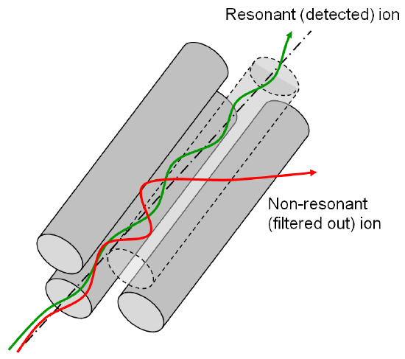

**Figure 1: A quadrupole mass analyser**

**TOF (Time of Flight) Mass Analyzer**

A time of flight mass spectrometer measures the mass-dependent time it takes ions of different masses to move from the ion source to the detector. This requires that the starting time (the time at which the ions leave the ion source) is well-defined. Therefore, ions are either formed by a pulsed ionization method (usually matrix-assisted laser desorption ionization, or MALDI), or various kinds of rapid electric field switching are used as a 'gate' to release the ions from the ion source in a very short time.TOF Analyzers separate ions by time without the use of an electric or magnetic field.

As time evolves, the ions (formed at the source) are separated. Ions of the same charges have equal kinetic energies.

$$t=L \sqrt{\frac{m}{e}\frac{1}{2V}}$$

Where t = time of flight; L =Length of tube m =mass of ion; e = charge of ion; V = applied voltage

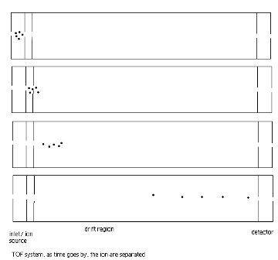

Figure 2: A TOF system.

**Magnetic Sector Mass Analyzer**

A magnetic sector alone will separate ions according to their mass-to-charge ratio. However, the resolution will be limited by the fact that ions leaving the ion source do not all have exactly the same energy and therefore do not have exactly the same velocity. This is analogous to the chromatic aberration in optical spectroscopy. To achieve better resolution, it is necessary to add an electric sector that focuses ions according to their kinetic energy. Like the magnetic sector, the electric sector applies a force perpendicular to the direction of ion motion, and therefore has the form of an arc.

In a magnetic deﬂection mass spectrometer, ions leaving the ion source are accelerated to a high velocity. The ions then pass through a magnetic sector in which the magnetic ﬁeld is applied in a direction perpendicular to the direction of ion motion. From physics, we know that when acceleration is applied perpendicular to the direction of motion of an object, the object's velocity remains constant, but the object travels in a circular path. Therefore, the magnetic sector follows an arc; the radius and angle of the arc vary with different ion optical designs.

The simplest mode of operation of a magnetic sector mass spectrometer keeps the accelerating potential and the electric sector at a constant potential and varies the magnetic field. Ions that have a constant kinetic energy, but different mass-to-charge ratio are brought into focus at the detector slit (called the 'collector slit") at different magnetic field strengths. The dependence of mass-to-charge ratio on the electric and magnetic fields is easily derived.

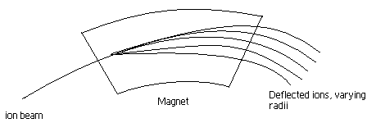

where m =mass of ion; e = charge of ion; B= strength of magnetic field; r = radius of curvature of analyzer tube; V = applied voltage

**Ion Cyclotron Resonance**

Ions move in a circular path in a magnetic field. The *cyclotron frequency* of the ion's circular motion is mass-dependent. By measuring the cyclotron frequency, one can determine an ion's mass.

$$ω=B\frac{e}{m}$$

Where $ω=cyclotron frequency$

**Ion trap mass analyzer**

[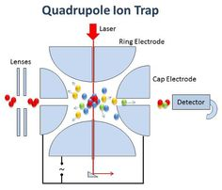](https://www.google.com/url?sa=i&url=https://www.pinterest.com/kermitm/quadrupole-ion-trap/&psig=AOvVaw0ZaQtOheJzIM_qH1zhc94s&ust=1585466229859000&source=images&cd=vfe&ved=0CAIQjRxqFwoTCLCciYbQvOgCFQAAAAAdAAAAABAD)

Consists of ring electrode and two end caps ◗ Principle very similar to quadrupole ◗ Ions stored by RF & DC fields ◗ Scanning field can eject ions of specific m/z

Ions are formed within the ion trap or injected into an ion trap from an external source. The ions are dynamically trapped by the applied RF potentials. The trapped ions can be manipulated by RF events.

**Applications of Mass Spectrometry (MS)**

* Environmental monitoring and analysis (soil, water and air pollutants, water quality, etc.)
* Geochemistry – age determination, soil and rock composition, oil and gas surveying
* Chemical and Petrochemical industry – Quality control
* Identify structures of biomolecules, such as carbohydrates, nucleic acids
* Sequence biopolymers such as proteins and oligosaccharides
* Determination of molecular mass of peptides, proteins, and oligonucleotides.
* Monitoring gases in patients’ breath during surgery.
* Identification of drugs abuse and metabolites of drugs of abuse in blood, urine, and saliva.
* Analyses of aerosol particles.
* Determination of pesticides residues in food

The Origin of Fragmentation Patterns

When the vaporized organic sample passes into the ionization chamber of a mass spectrometer, it is bombarded by a stream of electrons. These electrons have a high enough energy to knock an electron off an organic molecule to form a positive ion. This ion is called the **molecular ion - or sometimes the parent ion** and is often given the symbol M+ or http://www.chemguide.co.uk/analysis/masspec/mplusdot.GIF. The dot in this second version represents the fact that somewhere in the ion there will be a single unpaired electron. That's one half of what was originally a pair of electrons - the other half is the electron which was removed in the ionization process.

The molecular ions are energetically unstable, and some of them will break up into smaller pieces. The simplest case is that a molecular ion breaks into two parts - one of which is another positive ion, and the other is an uncharged free radical.

http://www.chemguide.co.uk/analysis/masspec/padding.GIFhttp://www.chemguide.co.uk/analysis/masspec/mfrag.GIF

The uncharged free radical will **not** produce a line on the mass spectrum. Only charged particles will be accelerated, deflected and detected by the mass spectrometer. These uncharged particles will simply get lost in the machine - eventually, they get removed by the vacuum pump.

The ion, X+, will travel through the mass spectrometer just like any other positive ion - and will produce a line on the stick diagram. All sorts of fragmentations of the original molecular ion are possible - and that means that you will get a whole host of lines in the mass spectrum. For example, the mass spectrum of pentane looks like this:

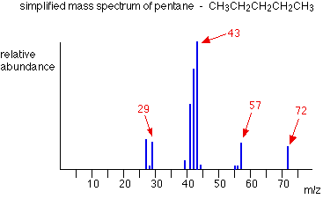

With an organic compound, each line represents a different fragment produced when the molecular ion breaks up.

In the stick diagram showing the mass spectrum of pentane, the line produced by the heaviest ion passing through the machine (at m/z = 72) is due to the [molecular ion](https://chem.libretexts.org/Bookshelves/Analytical_Chemistry/Supplemental_Modules_(Analytical_Chemistry)/Instrumental_Analysis/Mass_Spectrometry/The_Molecular_Ion_(M_)_Peak). The tallest line in the stick diagram (in this case at m/z = 43) is called the **base peak**. This is usually given an arbitrary height of 100, and the height of everything else is measured relative to this. The base peak is the tallest peak because it represents the commonest fragment ion to be formed - either because there are several ways in which it could be produced during fragmentation of the parent ion, or because it is a particularly stable ion.

**Using Fragmentation Patterns**

Example: Pentane

Let's have another look at the mass spectrum for pentane:



What causes the line at m/z = 57?

How many carbon atoms are there in this ion? There cannot be 5 because 5 x 12 = 60. What about 4? 4 x 12 = 48. That leaves 9 to make up a total of 57. How about C4H9+ then?

C4H9+ would be [CH3CH2CH2CH2]+, and this would be produced by the following fragmentation:

http://www.chemguide.co.uk/analysis/masspec/frageq1.GIF

The methyl radical produced will simply get lost in the machine.

The line at m/z = 43 can be worked out similarly. If you play around with the numbers, you will find that this corresponds to a break producing a 3-carbon ion:

http://www.chemguide.co.uk/analysis/masspec/frageq2.GIF

The line at m/z = 29 is typical of an ethyl ion, [CH3CH2]+:

http://www.chemguide.co.uk/analysis/masspec/frageq3.GIF

The other lines in the mass spectrum are more difficult to explain. For example, lines with m/z values 1 or 2 less than one of the easy lines are often due to loss of one or more hydrogen atoms during the fragmentation process.

Example: Pentan-3-one

This time the base peak (the tallest peak - and so the commonest fragment ion) is at m/z = 57. But this is not produced by the same ion as the same m/z value peak in pentane.

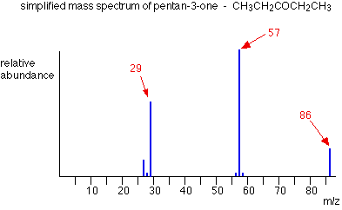

If you remember, the m/z = 57 peak in pentane was produced by [CH3CH2CH2CH2]+. If you look at the structure of pentan-3-one, it's impossible to get that particular fragment from it.

Work along the molecule mentally chopping bits off until you come up with something that adds up to 57. With a small amount of patience, you'll eventually find [CH3CH2CO]+ - which is produced by this fragmentation:

http://www.chemguide.co.uk/analysis/masspec/frageq4.GIF

You would get exactly the same products whichever side of the CO group you split the molecular ion. The m/z = 29 peak is produced by the ethyl ion - which once again could be formed by splitting the molecular ion either side of the CO group.

http://www.chemguide.co.uk/analysis/masspec/frageq5.GIF

**Peak Heights and Stability**

The more stable an ion is, the more likely it is to form. The more of a particular sort of ion that's formed, the higher its peak height will be

**Carbocations (carbonium ions)**

**Order of stability of carbocations**

primary < secondary < tertiary

Applying the logic of this to fragmentation patterns, it means that a split which produces a secondary carbocation is going to be more successful than one producing a primary one. A split producing a tertiary carbocation will be more successful still. Let's look at the mass spectrum of 2-methylbutane. 2-methylbutane is an isomer of pentane - isomers are molecules with the same molecular formula, but a different spatial arrangement of the atoms.

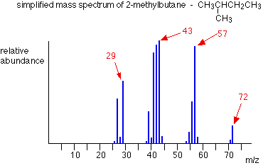

Look first at the very strong peak at m/z = 43. This is caused by a different ion than the corresponding peak in the pentane mass spectrum. This peak in 2-methylbutane is caused by:

http://www.chemguide.co.uk/analysis/masspec/padding.GIFhttp://www.chemguide.co.uk/analysis/masspec/frageq7.GIF

The ion formed is a secondary carbocation - it has two alkyl groups attached to the carbon with the positive charge. As such, it is relatively stable. The peak at m/z = 57 is much taller than the corresponding line in pentane. Again a secondary carbocation is formed - this time, by:

http://www.chemguide.co.uk/analysis/masspec/padding.GIFhttp://www.chemguide.co.uk/analysis/masspec/frageq6.GIF

You would get the same ion, of course, if the left-hand CH3 group broke off instead of the bottom one as we've drawn it. In these two spectra, this is probably the most dramatic example of the extra stability of a secondary carbocation.

**Acylium ions, [RCO]+**

Ions with the positive charge on the carbon of a carbonyl group, C=O, are also relatively stable. This is fairly clearly seen in the mass spectra of ketones like pentan-3-one.



The base peak, at m/z=57, is due to the [CH3CH2CO]+ ion. We've already discussed the fragmentation that produces this.

Note

The more stable an ion is, the more likely it is to form. The more of a particular ion that is formed, the higher will be its peak height.

**Using mass spectra to distinguish between compounds**

Suppose you had to suggest a way of distinguishing between pentan-2-one and pentan-3-one using their mass spectra.

|  |  |  |
| --- | --- | --- |
| pentan-2-one | http://www.chemguide.co.uk/analysis/masspec/padding.GIF | CH3COCH2CH2CH3 |
| pentan-3-one | http://www.chemguide.co.uk/analysis/masspec/padding.GIF | CH3CH2COCH2CH3 |

Each of these is likely to split to produce ions with a positive charge on the CO group. In the pentan-2-one case, there are two different ions like this:

* [CH3CO]+
* [COCH2CH2CH3]+

That would give you strong lines at m/z = 43 and 71. With pentan-3-one, you would only get one ion of this kind:

* [CH3CH2CO]+

In that case, you would get a strong line at 57. You don't need to worry about the other lines in the spectra - the 43, 57 and 71 lines give you plenty of difference between the two. The 43 and 71 lines are missing from the pentan-3-one spectrum, and the 57 line is missing from the pentan-2-one one.

The two mass spectra look like this:

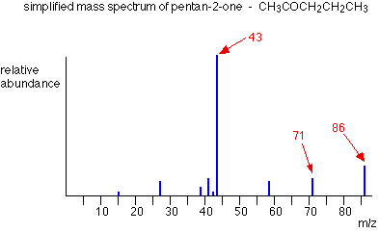

As you've seen, the mass spectrum of even very similar organic compounds will be quite different because of the different fragmentation patterns that can occur.

The Nature of Mass Spectra

A mass spectrum will usually be presented as a vertical bar graph, in which each bar represents an ion having a specific mass-to-charge ratio (m/z) and the length of the bar indicates the relative abundance of the ion. The most intense ion is assigned an abundance of 100, and it is referred to as the **base peak**. Most of the ions formed in a mass spectrometer have a single charge, so the m/z value is equivalent to mass itself. Modern mass spectrometers easily distinguish (resolve) ions differing by only a single atomic mass unit, and thus provide completely accurate values for the molecular mass of a compound. The highest-mass ion in a spectrum is normally considered to be the molecular ion, and lower-mass ions are fragments from the molecular ion, assuming the sample is a single pure compound.  
Atomic mass is given in terms of the **unified atomic mass unit** (symbol: μ) or **dalton** (symbol: Da). In recent years there has been a gradual change towards using the dalton in preference to the unified atomic mass unit. The dalton is classified as a "non-SI unit whose values in SI units must be obtained experimentally". It is defined as one twelfth of the rest mass of an unbound atom of carbon-12 in its nuclear and electronic ground state, and has a value of 1.660538782(83)x10-27 kg.  
The following diagram displays the mass spectra of three simple gaseous compounds, carbon dioxide, propane and cyclopropane. The molecules of these compounds are similar in size, CO2 and C3H8 both have a nominal mass of 44 Da, and C3H6 has a mass of 42 Da. The molecular ion is the strongest ion in the spectra of CO2 and C3H6, and it is moderately strong in propane. The unit mass resolution is readily apparent in these spectra (note the separation of ions having m/z=39, 40, 41 and 42 in the cyclopropane spectrum). Even though these compounds are very similar in size, it is a simple matter to identify them from their individual mass spectra. By clicking on each spectrum in turn, a partial fragmentation analysis and peak assignment will be displayed. Even with simple compounds like these, it should be noted that it is rarely possible to explain the origin of all the fragment ions in a spectrum. Also, the structure of most fragment ions is seldom known with certainty.

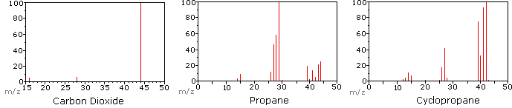

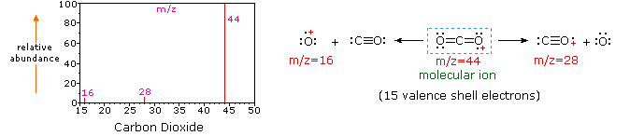

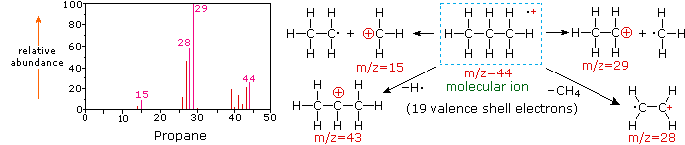

Since a molecule of carbon dioxide is composed of only three atoms, its mass spectrum is very simple. The molecular ion is also the base peak, and the only fragment ions are CO (m/z=28) and O (m/z=16). The molecular ion of propane also has m/z=44, but it is not the most abundant ion in the spectrum. Cleavage of a carbon-carbon bond gives methyl and ethyl fragments, one of which is a carbocation and the other a radical. Both distributions are observed, but the larger ethyl cation (m/z=29) is the most abundant, possibly because its size affords greater charge dispersal. A similar bond cleavage in cyclopropane does not give two fragments, so the molecular ion is stronger than in propane, and is in fact responsible for the the base peak. Loss of a hydrogen atom, either before or after ring opening, produces the stable allyl cation (m/z=41). The third strongest ion in the spectrum has m/z=39 (C3H3). Its structure is uncertain, but two possibilities are shown in the diagram. The small m/z=39 ion in propane and the absence of a m/z=29 ion in cyclopropane are particularly significant in distinguishing these hydrocarbons.

Most stable organic compounds have an even number of total electrons, reflecting the fact that electrons occupy atomic and molecular orbitals in pairs. When a single electron is removed from a molecule to give an ion, the total electron count becomes an odd number, and we refer to such ions as **radical cations**. The molecular ion in a mass spectrum is always a radical cation, but the fragment ions may either be even-electron cations or odd-electron radical cations, depending on the neutral fragment lost. The simplest and most common fragmentations are bond cleavages producing a neutral radical (odd number of electrons) and a cation having an even number of electrons. A less common fragmentation, in which an even-electron neutral fragment is lost, produces an odd-electron radical cation fragment ion. Fragment ions themselves may fragment further. As a rule, odd-electron ions may fragment either to odd or even-electron ions, but even-electron ions fragment only to other even-electron ions. The masses of molecular and fragment ions also reflect the electron count, depending on the number of nitrogen atoms in the species.

|  |  |  |
| --- | --- | --- |
| Ions with no nitrogen or an even # N atoms | odd-electron ions even-number mass | even-electron ions odd-number mass |
| Ions having an odd # N atoms | odd-electron ions odd-number mass | even-electron ions even-number mass |

This distinction is illustrated nicely by the following two examples. The unsaturated ketone, 4-methyl-3-pentene-2-one, on the left has no nitrogen so the mass of the molecular ion (m/z = 98) is an even number. Most of the fragment ions have odd-numbered masses, and therefore are even-electron cations. Diethylmethylamine, on the other hand, has one nitrogen and its molecular mass (m/z = 87) is an odd number. A majority of the fragment ions have even-numbered masses (ions at m/z = 30, 42, 56 & 58 are not labeled), and are even-electron nitrogen cations. The weak even -electron ions at m/z=15 and 29 are due to methyl and ethyl cations (no nitrogen atoms). The fragmentations leading to the chief fragment ions will be displayed by clicking on the appropriate spectrum. Repeated clicks will cycle the display.

|  |  |  |
| --- | --- | --- |
| mesoxid1.gif  mesoxid2.gif |  | 2etmeam1.gif  2etmeam2.gif |
| 4-methyl-3-pentene-2-one |  | N,N-diethylmethylamine |

When non-bonded electron pairs are present in a molecule (e.g. on N or O), fragmentation pathways may sometimes be explained by assuming the missing electron is partially localized on that atom. A few such mechanisms are shown above. Bond cleavage generates a radical and a cation, and both fragments often share these roles, albeit unequally.

Isotopes

Since a mass spectrometer separates and detects ions of slightly different masses, it easily distinguishes different isotopes of a given element. This is manifested most dramatically for compounds containing bromine and chlorine, as illustrated by the following examples. Since molecules of bromine have only two atoms, the spectrum on the left will come as a surprise if a single atomic mass of 80 Da is assumed for Br. The five peaks in this spectrum demonstrate clearly that natural bromine consists of a nearly 50:50 mixture of isotopes having atomic masses of 79 and 81 Da respectively. Thus, the bromine molecule may be composed of two 79Br atoms (mass 158 Da), two 81Br atoms (mass 162 Da) or the more probable combination of 79Br-81Br (mass 160 Da). Fragmentation of Br2 to a bromine cation then gives rise to equal sized ion peaks at 79 and 81 Da.

|  |  |  |  |  |
| --- | --- | --- | --- | --- |
| br2.gif |  | vnylcl.gif |  | ch2cl2.gif |
| bromine |  | vinyl chloride |  | methylene chloride |

The centre and right hand spectra show that chlorine is also composed of two isotopes, the more abundant having a mass of 35 Da, and the minor isotope a mass 37 Da. The precise isotopic composition of chlorine and bromine is:

* **Chlorine:** 75.77% 35Cl and 24.23% 37Cl
* **Bromine:** 50.50% 79Br and 49.50% 81Br

The presence of chlorine or bromine in a molecule or ion is easily detected by noticing the intensity ratios of ions differing by 2 Da. In the case of methylene chloride, the molecular ion consists of three peaks at m/z=84, 86 & 88 Da, and their diminishing intensities may be calculated from the natural abundances given above. Loss of a chlorine atom gives two isotopic fragment ions at m/z=49 & 51 Da, clearly incorporating a single chlorine atom. Fluorine and iodine, by contrast, are monoisotopic, having masses of 19 Da and 127 Da respectively. It should be noted that the presence of halogen atoms in a molecule or fragment ion does not change the odd-even mass rules given above.

**The Nitrogen Rule**

The nitrogen rule states that a molecule that has no or even number of nitrogen atoms has an even nominal mass, whereas a molecule that has an odd number of nitrogen atoms has an odd nominal mass.

eg. 1:

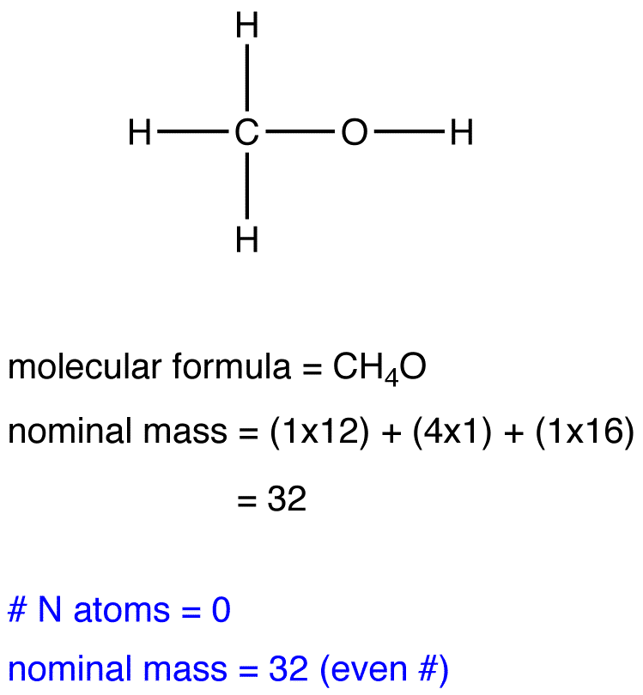

eg. 2:

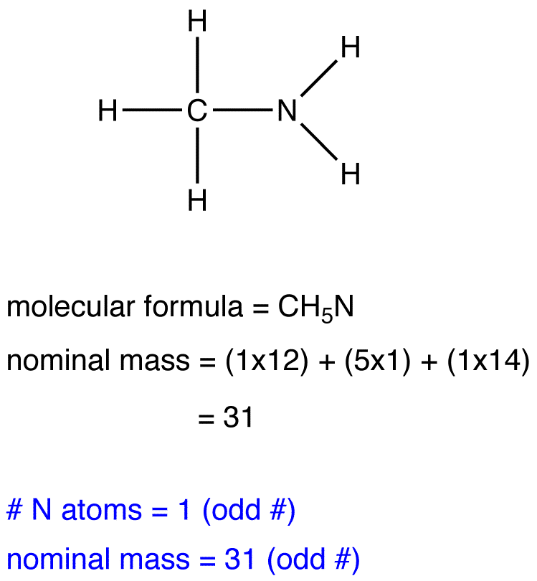

eg. 3:

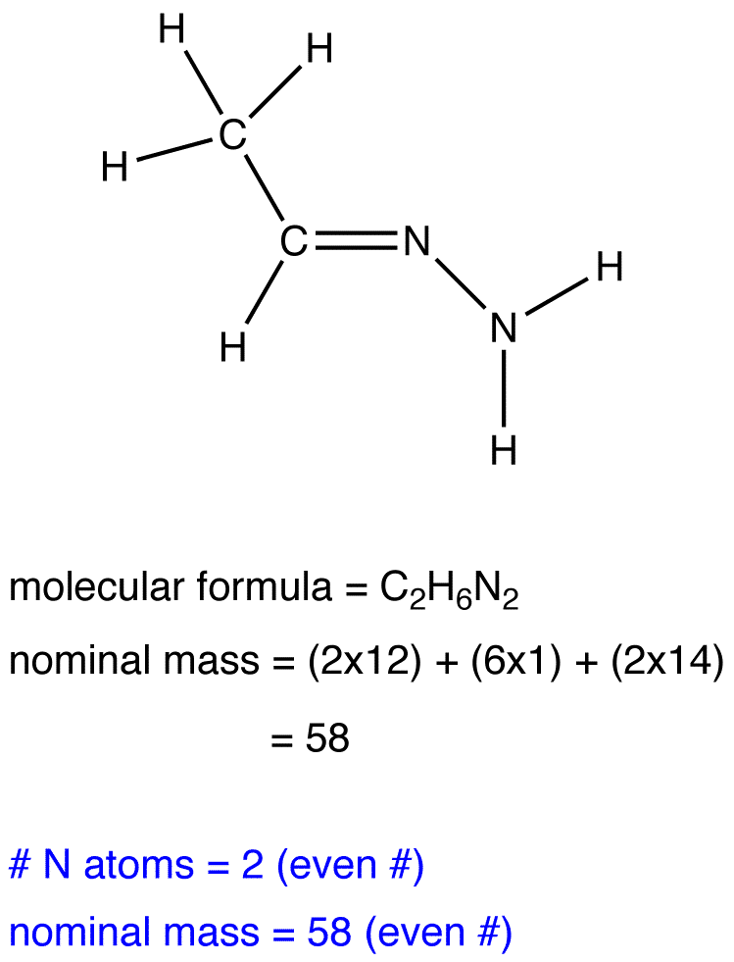

**Index of Hydrogen Deficiency (IHD)**

In a hydrocarbon where all the C atoms have only single bonds and no rings are involved, the compound would have the maximum number of H atoms. If any of the bonds are replaced with double or triple bonds, or if rings are involved, there would be a “deficiency” of H atoms. By calculating the index of hydrogen deficiency (IHD), we can tell from the molecular formula whether and how many multiple bonds and rings are involved. IHD is also called the [Degree of Unstaturation](https://chem.libretexts.org/Bookshelves/Organic_Chemistry/Supplemental_Modules_(Organic_Chemistry)/Alkenes/Properties_of_Alkenes/Degree_of_Unsaturation). This will help cut down the possibilities one has to consider in trying to come up with all the isomers of a given formula.

Here is a summary of how the index of hydrogen deficiency (IHD) works.

* *A double bond and ring each counts as one IHD.*
* *A triple bond counts as two IHD.*

[Hydrocarbons](https://chem.libretexts.org/Bookshelves/Organic_Chemistry/Supplemental_Modules_(Organic_Chemistry)/Hydrocarbons) (*CxHy*) :

IHD=2x+2−y/2

(where *x* and *y* stand for no. of C and H respectively.

|  |
| --- |
| **Example 1** |
| IHD for *C*2*H*4 is  2(2) +2−4/2=1  This means it can have either one double bond or one ring, but it cannot have a triple bond. Since you cannot form a ring with only two C’s, it must have a double bond. |
| **Example 2** |
| IHD for *C*4*H*6 is  2(4) +2−6/2=2  This means it can have either one double bond and a ring such as or two double bonds such as CH2=CH−CH=CH2 or CH2=C=CH−CH3 or two rings , or one triple bond, such as CH3C≡CCH3. |

**Compounds Containing Elements Other than C and H**

O and S atoms do not affect the IHD.

* Halogens (F, Cl, Br, I) are treated like H atoms (CH2Cl2 has the same IHD as CH4).
* For each N, add one to the number of C and one to the number H (CH5N is treated as C2H6. CH4N2O is treated as C3H6 by adding 2 to # of C and 2 to # of H).

Do not forget that when double bonds and rings are involved, geometric isomers are possible.

**Practice problems**

Calculate the IHD of

CH3C≡CCOCH3

**Answer** IHD = 3